PROJECT REPORT ON

**GRACIOUS_GARMENTS**

USING

HTML 5 & PHP - MYSQL

**Student (Leader): HIEU VI MINH**

**Student: VAN TRAN THUY**

**Student: THONG VU MINH**

**Student: GIANG TRAN TRUONG**

**CONTENTS**

1. Acknowledgements
2. eProject Synopsis
3. eProject Analysis
4. eProject Design
5. DFD’s
6. FlowCharts
7. Process Diagrams
8. Database Design / Structure
9. Screen Shot’s
10. Source Code with Comments
11. User Guide
12. Developer’s Guide

**ACKNOWLEDGEMENTS**

We would like to thank Aptech Education System and all Teachers for giving me the opportunity and enviroment to learn about HTML5, PHP. This was quite a great experience we can learn from. It helped me to explore my skills and increased my interest in web development (Front hand/Backend).

**INTRODUCTION**

Computer plays an important role in our daily life. Anything we want we can get only in one mouse click. Speed, reliability and accuracy of the computer make it a powerful tool for different purposes. A very important and basic need of today’s modern business world is the quick availability and processing of information using computer. One can easily get the type of required information within a fraction of a second. The project that I have taken is also in this category which is used in our daily life whenever we want to purchase some items we can easily get them at our home.

## Objective:

## The objective of project on GRACIOUS_GARMENTS is to developing a GUI based automated system, which will cover all the information Related to the all products which is used in our daily life. For example – Mobiles Phones, Laptops, Clothes, Books, Electronic Items and many more. So by this GUI based automated system a user want to purchase something then it only a mouse click away to purchase these products.

## Need of ONLINE SHOPPING PORTAL

The “**GRACIOUS_GARMENTS**” is developed according the current need in different Fields. This is online shopping Website which provides facility for purchasing clothes. So by using this GRACIOUS_GARMENTS users which want to purchase some products will first Register an account on this portal then Login through their Username and Password, and show the products, brands at home pages.

**EPROJECT SYNOPSIS**

* Before Login
  + Login
  + Register
  + Administrator Login
  + Contact Us
* After Administrator Login
  + Add/ Edit/Delete Brands
  + Add/ Edit/Delete Products
  + Logout
* After User Login
  + Logout

1) The Home Page should be created making use of Frames with a suitable logo.

2) Home Page should contain details of different Garments with suitable images.

3) The site should display a menu which will contain the options for brief

introduction about the various garments available, location of the shop and

any other information if required.

4) The information should be categorized according to the brand names of the

products like if a User wants to see only “Van Heusen” products or any other

companies products then he/she can click on a Link/button/menu etc and can

see only that Brand products.

5) When a user selects any particular brand, a list of products for that brand will

be displayed

6) A brief summary of features of individual products should be displayed on the Web Page along with the product but detailed Features should be stored in

Individual Word documents which can be downloaded or viewed by the User

who wishes to see the same.

7) The user should also be able to compare the various products of different as

well as similar brands.

8) There should be a “Contact Us” page which will have the Address of the

Company which is as follows and the mail address which when clicked will

invoke the local mail client from where they can send an email. Address of the

Company should be displayed using GeoLocation API (eg. GoogleMaps).

**PROJECT PLAN**

**DEFINING A PROBLEM**

* Define a problem.
* Justify the needs for a computerized solution.
* Identify the functions to be provided by the systems along with the constraints.
* Determine goal and requirements of the system.
* Establish the high level acceptance criteria.

**DEVELOPING A SOLUTION STRATEGY**

* Outline several solution strategies. Do not consider constraints for the time being.
* Conduct a feasibility strategy, including why the other strategies are rejected.
* Develop a list of priorities for the product characteristics.

PLANNING THE DEVELOPMENT PROCESS

* Define a life cycle model and an organizational structure for the project.
* Plan the configuration management, quality assurance and validation activities.
* Establish the preliminary cost estimates, the schedule and the staffing estimates for System development.
* Develop preliminary estimates for the computing resources required to operate and maintain the system.

**Front End Details**

Front End tool is used for give a Graphical user interface to system. By this we can make a system user friendly and more capable. I have chosen PHP as front end tool. Because it is an Open Source Technology, freely available and more familiar with any type of database.

**Back End Details**

Back end part of a system is more important because it controls all the internal process of a system. I have choose oracle database as back end. Because it is word’s Most Capable relational database and provide more security than others.

**Why MySQL?**

MySQL is the world's most popular open source database software, with over 100 million copies of its software downloaded or distributed throughout its history. With its superior speed, reliability, and ease of use, MySQL has become the preferred choice for Web, Web 2.0, SaaS, ISV, Telecom companies and forward-thinking corporate IT Managers because it eliminates the major problems associated with downtime, maintenance and administration for modern, online applications.

Many of the world's largest and fastest-growing organizations use MySQL to save time and money powering their high-volume Web sites, critical business systems, and packaged software — including industry leaders such as Yahoo!, Alcatel-Lucent, Google, Nokia, YouTube, Wikipedia, and Booking.com.

The flagship MySQL offering is MySQL Enterprise, a comprehensive set of production-tested software, proactive monitoring tools, and premium support services available in an affordable annual subscription.

MySQL is a key part of WAMP (Window, Apache, MySQL, PHP), the fast-growing open source enterprise software stack. More and more companies are using WAMP as an alternative to expensive proprietary software stacks because of its lower cost and freedom from platform lock-in.

**EPROJECT ANALYSIS STEPS**

Draw context

Diagram

Draw Prototypes

Model The Requirement

Requirement

Finalize The Requirement

Requirement

**Draw Context Diagrams** – The context diagram is a simple model that defines the boundaries and interfaces of the proposed system with the external world. It identifies the entities outside the proposed system that interact with the system

**Development Of Prototype** – One effective way to find out what the customer really wants is to construct a prototype, something that looks and preferably acts like a part of the system they want.

**Model The Requirement** – This process really consist of various graphical representations of functions, data entities, external entities and the relationship between them. The graphical view may help to find incorrect, inconsistent, missing and superfluous requirement.

**Finalize The Requirements** – After modeling the requirements we will have better understanding of the system behavior. The inconsistencies and ambiguities have been identified and corrected.

**FUNCTIONAL REQUIREMENTS**

Functional requirements define the fundamental actions that must take place in the software in accepting the inputs and in processing and generating the outputs. These are listed as “shall” statements starting with “The system shall….

**Login Module** – This module is provided for administrator and users such as Product buyer and seller who have registered themselves in the system. These login are provided according to the need of the systems.

* + - **Input –** User id and password
    - **Process** – After entering user id and password by user process of validation occur to identify whether user id and password is available in database or not.
    - **Output** – Registered user can access website and can use the services.

**Administrator Module** – The administrator is provided with password and login-id with which he/she can access the system. Administrator is provided right of maintaining the database, verifies registered users.

* + - **Input** – Login id and password.
    - **Process** – Process of validation will occur.
    - **Output** – Administrator will maintain the database and will perform Product seller process.

**Function available to general user-**

* User can access the information about various Products and Brands.
* User can buy a Product online.

**Function available to Administrator**

* Administrator will add or delete the Products in the database.
* Administrator can edit Products/ Brands.

**FLOWCHART**

*Operation/data processing*

Products / Cart /

Login / Index

*Authentication*n

**Online Shopping Portal Database**

**DFD’S**

**For Registration**

User

Details

Username Exists

Success

**E-R Diagram**

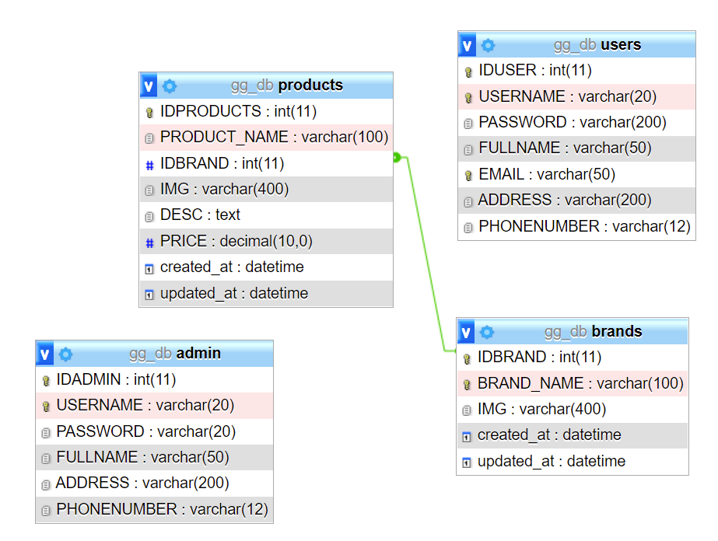

**BIBLOGRAPHY**

This document contains provisions which, through reference in this text, constitute provisions of the present document.

1. Google Search Engine for various searching
2. Keeves PHP- MYSQL
3. Online at [www.w3schools.org](http://www.w3schools.org)

# SCREEN SHOT’S

**SOURCE CODE WITH COMMENTS**